AUTOMATIC STREET LIGHT CONTROL SYSTEM
A Electronic Design Workshop report submitted to

NARAYANA ENGINEERING COLLEGE(AUTONOMOUS), NELLORE
(Affiliated to Jawaharlal Nehru Technological University Anantapur ,Ananthapuramu)



InpartialfulfillmentoftherequirementsfortheawardofDegreeof
BACHELOR OF TECHNOLOGY
IN
ELECTRONICSANDCOMMUNICATIONENGINEERING BY
KOTA SRIHAASA(22711A0492)
SHAIK AFRIN(22711A04B6)
G.SRAVANTHI(22711A0483)
G.DEEKSHITHA(23715A0407)

Undertheguidanceof
Mrs.A.VIDYULATHA, M.Tech
Associate Professor

DEPARTMENTOFELECTRONICSANDCOMMUNICATION

ENGINEERING

May-2025


DEPARTMENTOFELECTRONICSANDCOMMUNICATIONENGINEERING

CERTIFICATE
This is to certify that the Electronic Design Workshopreport entitled “AUTOMATIC STREET LIGHT CONTROL SYSTEM” is the bonafied work done by Kota Srihaasa(22711A0492), Shaik Afrin(22711A04b6),G.Sravanthi(22711A0483)andG.Deekshitha(23715A0408)andinthepartialfulfillmentoftherequirementsfortheawardofDegree ofBACHELOROFTECHNOLOGYinELECTRONICS&COMMUNICATIONENGINEERINGduringthe academicyear2024-2025

SignatureoftheGuide Signatureof the H.O.D.
A.Vidhyulatha,M. Tech Dr. K.Murali,M. Tech,Ph. D
Associate Professor Professor&H.O.D.
DepartmentofECE DepartmentofECE
NarayanaEngineeringCollege NarayanaEngineeringCollege
Nellore-524004 Nellore-524004

DateofExternalVivaVoce

Internalexaminer Externalexaminer

ACKNOWLEDGEMENT

We thank our project supervisor A.VIDYULATHA, M.Tech Associate Professor, Department of Electronics and Communication Engineering, Narayana Engineering College, Nellore for his guidance, valuable suggestions and support in the completion of the Electronic Design Workshop.
We would like to express my deep sense of gratitude and my sincere thanks to Dr.K.Murali, M.Tech,Ph.D, HOD, Department of Electronics and Communication Engineering, Narayana Engineering College, Nellore for providing the necessary facilities and encouragement towards the Electronic Design Workshop.
We would like to express our profound gratitude to Principal Dr.G.SRINIVASULU REDDY, M.Tech,Ph.D, Narayana Engineering College, Nellore for providing the required facilities.
We are thankful to our director Dr. B.DATTATRAYA SARMA, Narayana Engineering and Pharmacy Colleges who took keen interest and encouraged me in every effort throughout this course.
We are extremely grateful to Sri.V. VIJAYA BHASKAR REDDY, General Manager, Narayana Educational Institutions, Andhra Pradesh for their blessings.
WeareextremelygratefultoMr.K.PUNEET,President,NarayanaEducational Institutions, India for their coordination.
We are extremely grateful to Dr.P.NARAYANA, Ph.D, Founder, Narayana Educational Institutions, India for providing everything needed and supporting in everywhere.
We gratefully acknowledge and express our thanks to the teaching andthenon-teaching staff of E.C.E department.
We would like to express our love and affection to our parents for their support and encouragement throughout this Electronic Design Workshop.

Project Associates
Kota Srihaasa (22711A0492)
Shaik Afrin (22711A04B6)
G.Sravanthi (22711A0483)
G.Deekshitha (23715A0407)

ABSTRACT

This project presents the design and implementation of an Automatic Street Light Control System using a Light Dependent Resistor (LDR), aimed at conserving energy and reducing manual intervention. The system operates by detecting the intensity of ambient light using an LDR sensor, which varies its resistance based on the surrounding light levels. When the light level falls below a predefined threshold, indicating dusk or darkness, the circuit automatically switches ON the street light. Conversely, when daylight is detected, the light is turned OFF, thereby optimizing energy usage.
This simple yet effective system eliminates the need for manual control and significantly reduces electricity wastage, especially in public lighting systems. Unlike complex microcontroller-based designs, this project utilizes basic electronic components such as LDR, resistors, transistors, and a relay module, making it cost-effective, easy to build, and suitable for widespread implementation in both rural and urban areas. The proposed model is scalable and can be further enhanced by integrating solar power, motion sensors, or IoT capabilities for smart city applications.
The automatic street lighting system enhances operational efficiency, minimizes human error, and supports environmental sustainability through intelligent energy management. Its low maintenance and minimal component requirements make it ideal for educational, experimental, and real-time infrastructure deployments.

CONTENTS

Abstract Contents  List ofFigures | iii  iii
CHAPTER1 INTRODUCTION | 1-2
1.1 Introduction | 1-2
1.2 Purpose | 2
CHAPTER2LITERATURE SURVEY | 3-5
2.1Existing Systems | 4-5
CHAPTER3 METHODOLOGY | 6-22
3.1Battery  3.1.1Battery Working | 6-7  6-8
3.2Hardware Description | 8-13
3.2.1Hardwarecomponents | 8
3.2.2LDR | 8-9
3.2.3 Relay Module | 9-10
3.2.4LED | 10-11
3.2.5Transistor | 11
3.2.6Power Supply | 11
3.2.7Wiring and Connectors | 11-12
3.3 Block Diagram | 13-14
3.4 Schematic Diagram | 15
3.5Principle of Operation | 15-17
3.6Final Hardware Model | 17-19
3.7Hardware Testing | 19-20
3.8Advantages | 21
3.9Disadvantages | 22
CHAPTER4 APPLICATIONS  CHAPTER5 CONCLUSION AND FUTURESCOPE  5.1 Conclusion | 23-27  28-35  28-30
5.2 Future Scope | 31-35
REFERENCES | 36

LISTOFFIGURES
Fig3.2.1(1)LDR 9
Fig3.2.2(1)Relay Module 10
Fig3.3.1LED 11
Fig3.4.1Transistor 12
Fig3.5.1Wiring and Connectors 13
Fig3.6Block Diagram 13
Fig3.7Schematic Diagram 14
Fig3.8Hardware Testing 21

CHAPTER–1
INTRODUCTION

INTRODUCTION
Street lighting plays a vital role in urban and rural infrastructure by enhancing visibility, ensuring public safety, and preventing accidents or criminal activity during nighttime. However, traditional street lighting systems often rely on manual switching or fixed timers, which can be inefficient. These systems may keep lights on even when natural daylight is sufficient or when there is no human activity on the roads, leading to unnecessary energy consumption and increased operational costs.
To address these challenges, the Automatic Street Light Control System presents an innovative and energy-efficient solution that automates the operation of street lights based on real-time environmental conditions. This system utilizes various sensors—primarily Light Dependent Resistors (LDRs) and motion detectors—to monitor the surrounding light intensity and movement. When the ambient light drops below a certain threshold (such as at dusk or during overcast conditions), the street lights are automatically turned on. Conversely, when sufficient natural light is detected (like during daytime), the system switches the lights off.
In more advanced configurations, infrared (IR) sensors or passive infrared (PIR) motion sensors can be integrated to detect the presence of vehicles or pedestrians. In such systems, the lights are turned on only when movement is detected in the area, and automatically turned off after a period of inactivity. This intelligent lighting mechanism not only saves electricity but also extends the lifespan of the lighting equipment by reducing unnecessary usage.
The system can be implemented using microcontrollers such as Arduino, Raspberry Pi, or Programmable Logic Controllers (PLCs), which process the sensor inputs and control the lighting accordingly. With the integration of IoT (Internet of Things) technologies, these systems can even be remotely monitored and managed via mobile apps or web interfaces, allowing for more advanced features like fault detection, performance monitoring, and energy consumption analytics.
By reducing manual intervention and minimizing energy waste, the Automatic Street Light Control System aligns with modern goals of smart city development and sustainable energy management. It not only optimizes electricity usage but also contributes to environmental conservation by lowering carbon emissions associated with power generation.

PURPOSE
The primary purpose of the Automatic Street Light Control System is to design and implement an intelligent lighting solution that enhances energy efficiency, reduces human intervention, and supports the development of smart infrastructure. By automatically controlling the operation of street lights based on real-time environmental data—such as ambient light levels or the presence of vehicles and pedestrians—the system aims to:
Minimize Energy Wastage: Automatically turning lights on only when needed helps significantly reduce electricity consumption.Reduce Operational Costs: Lower energy use and less frequent maintenance (due to optimized lighting duration) lead to cost savings for municipalities and private infrastructure operators.Improve Public Safety: Ensuring that lights are always on during low-light conditions or when movement is detected increases visibility and safety for road users and pedestrians.Enable Automation: Eliminates the need for manual switching or fixed-timer systems, making the operation more reliable and consistent.Support Sustainable Development: Promotes eco-friendly practices by reducing carbon footprint and aligning with smart city and green energy initiatives.Increase System Intelligence: Potentially integrate with IoT for remote monitoring, fault detection, and performance analytics, making the system adaptable for future smart city applications.

CHAPTER–2

LITERATURESURVEY

Street lighting is an essential element of public infrastructure, crucial for maintaining road safety, preventing accidents, and enhancing urban security during nighttime hours. Over the years, various street lighting control systems have been developed and deployed in different parts of the world. These systems range from simple manual operations to highly sophisticated smart lighting networks. While each has its own merits, the limitations of older or less intelligent systems often lead to unnecessary energy consumption, high operational costs, and inefficient management. Understanding the strengths and weaknesses of these existing systems is key to appreciating the importance and innovation behind the proposed Automatic Street Light Control System.

2.1 Manual Switching Systems
One of the earliest and most basic methods of street light control is the manual switching system. In this system, street lights are operated manually by field technicians or maintenance personnel who are responsible for turning them on in the evening and off in the morning. The process often follows a fixed schedule or personal judgment based on the technician’s observation of ambient lighting conditions.
Despite its simplicity, manual switching is highly inefficient and outdated in today’s context. It is labor-intensive and subject to human error. For example, lights might be left on during daylight hours due to negligence or operational delays, leading to wasted electricity. Conversely, delays in turning on the lights in the evening can pose safety hazards for road users. In rural or less-developed areas, this method is still common due to budget constraints or lack of access to modern technologies. However, it lacks consistency, scalability, and responsiveness, making it unsuitable for growing urban centers.
2.2Timer-Based Systems
As a step forward from manual operation, timer-based systems were introduced to automate the switching process. These systems use programmable electronic timers to turn the lights on and off at predetermined times, typically aligned with average sunrise and sunset hours. Timers are set based on seasonal estimates and do not require human intervention on a daily basis, which reduces labor costs and improves regularity.
While timer-based systems are more efficient than manual systems, they still fall short in terms of adaptability. The biggest drawback is their inability to respond to real-time environmental changes. For instance, during cloudy or stormy weather when natural light levels drop earlier than usual, the lights remain off until the programmed time. Similarly, they may switch on during early evenings when there is still sufficient daylight. Over time, these discrepancies accumulate, resulting in energy wastage or reduced effectiveness in providing illumination when it’s actually needed. Adjusting the timer settings to reflect seasonal changes also requires periodic maintenance and programming, which adds complexity.
2.3Photocell or LDR-Based Systems
To create a more responsive lighting system, photocell or Light Dependent Resistor (LDR) based control mechanisms were introduced. These systems use LDR sensors to detect the level of ambient light in the environment. When the natural light intensity drops below a certain threshold, such as during dusk or cloudy conditions, the street lights are automatically turned on. Conversely, when the light level increases above the threshold—typically during daylight—they are turned off.
This method offers a significant improvement over timer-based systems as it reacts directly to environmental light levels in real-time. It ensures that the lights operate only when truly necessary, reducing the chances of unnecessary energy usage. However, the LDR-only system has its own limitations. It lacks the intelligence to differentiate between types of low-light conditions, such as temporary darkness caused by a passing cloud versus actual nightfall. Moreover, these systems typically turn on all lights regardless of whether there's human or vehicular activity, leading to potential overuse of lighting in low-traffic areas.

2.4Motion Sensor-Based Systems
To further optimize energy usage, motion sensor-based systems were developed. These systems integrate Passive Infrared (PIR) sensors, ultrasonic sensors, or microwave sensors to detect movement in the vicinity of the street lights. The principle behind this system is simple: lights turn on only when motion—such as that of a pedestrian, cyclist, or vehicle—is detected within a specific range. After a predefined delay, if no further motion is detected, the lights are automatically turned off or dimmed.
This system significantly reduces electricity consumption in areas with low or intermittent traffic, such as residential streets, alleys, or highways during off-peak hours. In addition to energy efficiency, it also adds a sense of dynamic lighting that enhances security by alerting individuals to movement in otherwise dark environments.
However, motion sensor systems also come with their own challenges. Poor calibration can lead to frequent false triggers (e.g., from animals, wind, or debris), causing the lights to turn on unnecessarily. On the other hand, sensors may fail to detect certain types of motion, resulting in a delay or complete absence of illumination when needed. Additionally, the frequent switching on and off may reduce the lifespan of the lighting units unless supported by smart dimming mechanisms.

2.5IoT-Based Smart Lighting Systems
With the emergence of smart city concepts and the Internet of Things (IoT), the latest generation of street lighting systems integrates digital communication and cloud-based monitoring. These IoT-based smart lighting systems consist of street lights embedded with sensors and wireless communication modules. These lights are connected to a centralized control system that allows for remote operation, real-time monitoring, fault detection, adaptive brightness control, and energy usage analytics.IoT systems offer unmatched flexibility and intelligence. They can dynamically adjust the brightness of lights based on environmental data, motion detection, and even external inputs such as weather forecasts or traffic density. Maintenance teams can receive alerts when a light malfunctions, allowing for quicker response times. Additionally, data collected from the lighting system can help city planners make informed decisions regarding energy policy and infrastructure upgrades.However, the implementation of IoT-based systems is costly, both in terms of hardware and infrastructure. They require stable internet connectivity, regular software updates, and robust cybersecurity measures to prevent unauthorized access. For developing regions or small municipalities with limited budgets, such solutions may currently be impractical.

CHAPTER-3
METHODOLOGY

BATTERY
A reliable power supply is essential for the effective operation of an automatic street light control system, especially in areas where grid power is unavailable or inconsistent. Using a battery as the primary or backup power source ensures uninterrupted functionality of the system during night hours or power outages. In solar-powered versions of this project, the battery becomes a crucial component for storing energy generated during the day and supplying it during the night.
.3.1.1 WORKING OF BATTERY:
In the Automatic Street Light Control System, the battery is a critical component that ensures the system operates continuously, especially during the night or when there is no access to the electrical grid. The battery functions by storing energy during the day and supplying power to the system during the night when the street lights need to be activated. This energy storage mechanism becomes especially important in solar-powered systems, where the battery stores excess energy generated by solar panels during the day, making it available for use at night when the lights are needed.
The battery's charging phase begins during the day, typically when sunlight is available. In a solar-powered system, the solar panels convert sunlight into electrical energy. This energy is then routed through a solar charge controller, which regulates the charging process to prevent the battery from overcharging, ensuring its longevity and safety. The solar charge controller directs the appropriate amount of voltage and current into the rechargeable battery, typically a 12V Lead-Acid or Lithium-Ion battery, depending on the design and requirements of the system. The battery stores this energy in the form of chemical energy, preparing for discharge during the night.
As the day transitions into night, the system switches to its discharge phase. The LDR (Light Dependent Resistor) sensor detects the reduction in ambient light as the sun sets or due to weather conditions, signaling the microcontroller to activate the street lights. When this occurs, the stored energy in the battery is released to power the microcontroller, the motion sensors (PIR sensor), and the street lights. The system can be programmed to turn the lights on based on ambient light levels or when motion is detected in the area. If motion is detected by the PIR sensor, the lights remain on. However, if no motion is detected for a predefined period, the microcontroller may turn the lights off or dim them to save energy.
The battery’s role is crucial for power management. It is important for the system to prevent both overcharging and over-discharging of the battery, as either of these conditions can shorten the battery's lifespan or lead to failure. This is where the Battery Management System (BMS) or the charge controller plays an essential role. The BMS ensures that the battery operates within safe voltage levels, prevents deep discharges, and may even cut off the power supply if the voltage drops below a critical level, protecting the battery from potential damage. Additionally, it may also monitor other aspects of the battery’s health, such as temperature and current flow, to ensure optimal performance.
Throughout the entire operation, the battery enables the system to be autonomous and independent of the electrical grid. In systems that use solar energy, the battery allows for the efficient use of renewable energy by storing solar power during the day and releasing it at night. This reduces dependency on the grid and enhances energy efficiency. The battery also ensures that the street lights can continue to function during power outages or in areas that do not have access to grid electricity, making it an ideal solution for rural or off-grid locations.
The cycle of charging and discharging is what makes the battery such an integral part of the system. During daylight, the battery is in the charging phase, storing energy for later use. Once darkness falls, the battery switches to the discharging phase, supplying power to the street lights and the control system. In this way, the battery ensures the system’s operation throughout the night, providing reliable lighting when it's needed the most.
In terms of battery capacity, the energy stored in the battery must be sufficient to power the entire system throughout the night. For example, if the system consumes 1A of current for the street light and the control system, a 12V, 7Ah battery would provide about 7 hours of operation (assuming ideal conditions). This capacity can be adjusted based on the power consumption of the system and the required runtime.
In summary, the battery in the Automatic Street Light Control System acts as both a power storage unit and a power supply, ensuring the system operates reliably, efficiently, and autonomously. It plays a crucial role in maintaining the functionality of the system, whether it’s solar-powered or connected to the electrical grid. By storing energy during the day and supplying it during the night, the battery reduces energy consumption, supports off-grid operation, and improves the overall sustainability of the street lighting system.

3.2HARDWAREDESCRIPTION

3.2.1Hardwarecomponents

1.Light Dependent Resistor (LDR)

2.Relay Module

3.Street Light (LED or CFL)

4.Transistor (Switching Device)

5.Power Supply

6.Wiring and Connectors

In this specificAutomatic Street Light Control Systemproject, we focus solely on the use of aLight Dependent Resistor (LDR)as the primary component for controlling the street light based on ambient light conditions. The system's design is simplified to use only an LDR sensor to automatically switch the street light on at dusk and off at dawn. Here's an in-depth breakdown of the hardware components used in this simplified system.

1. Light Dependent Resistor (LDR)
The LDR is the heart of this system, and its function is to detect the ambient light conditions to determine whether the street light should be on or off. Functionality: An LDR is a type of variable resistor whose resistance changes based on the amount of light falling on it. When exposed to light, the LDR has a low resistance, allowing current to flow through it easily. However, in low-light conditions (such as during nighttime), the LDR’s resistance increases, limiting the flow of current and triggering the system to turn on the street light.
Working Principle: The LDR is used in a voltage divider configuration, where it is paired with a fixed resistor. The voltage across the LDR varies as the light intensity changes. The output of this voltage divider is fed to a control circuit that compares it against a preset threshold to determine if the light should be activated. If the ambient light level is below the threshold, the system will turn the light on; if the light level is above the threshold, the light will remain off.
This method is ideal for an automatic light control system, as it eliminates the need for manual intervention or complex sensors. The LDR allows the system to function autonomously, responding to the natural change in light levels throughout the day.


Figure 3.2.1(1)

2. Relay Module
The relay module is responsible for controlling the street light based on the signal it receives from the LDR. While the LDR detects the ambient light, it needs a switching mechanism to activate the high-power street light. The relay allows the low-power LDR circuit to control the high-power street light without direct electrical contact.
Functionality: The relay acts as a switch. When the control circuit (based on the LDR's input) determines that the light should be on (i.e., at night or in low-light conditions), the relay is activated, allowing current to flow to the street light. When the ambient light level rises in the morning, the relay deactivates, cutting the power to the light and turning it off.
Working Principle: The relay is connected to the control circuit, which receives the signal from the LDR. When the light level drops and the LDR detects darkness, the relay’s switch is closed, allowing electricity to flow to the street light. The relay’s role is crucial as it allows for the switching of a high-power load (the street light) using a low-power control signal.The relay is typically activated by a transistor or a simple switching circuit that amplifies the signal from the LDR before reaching the relay.
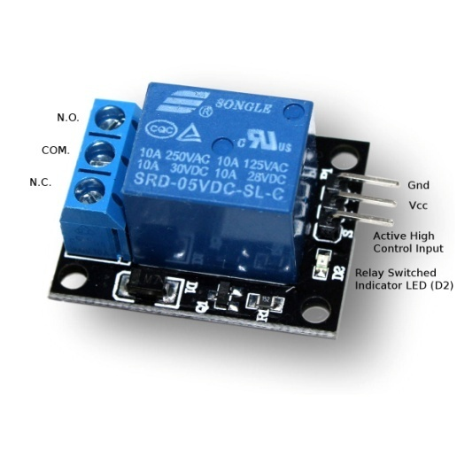
Figure 3.2.2(1)
3. Street Light (LED or CFL)
The street light is the load that is controlled by the relay in response to the signal from the LDR.Functionality: The street light is the main output component of the system, and its role is to provide illumination to the street when triggered by the system. In this project, the street light will automatically turn on when the ambient light levels are low, such as during nighttime or cloudy conditions. In the morning, when sunlight restores the ambient light levels, the street light will automatically switch off.
LED vs. CFL: The type of street light used depends on factors like energy efficiency and cost. LED lights are a preferred choice due to their high efficiency, longer lifespan, and low energy consumption. CFLs are also energy-efficient but have a shorter lifespan and are more prone to breakage.Choosing energy-efficient lighting such as LEDs helps further reduce the overall energy consumption of the system, making it more sustainable and cost-effective over time.

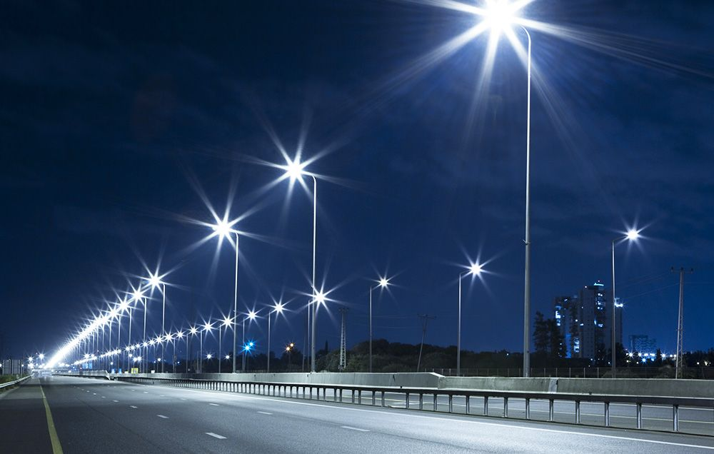
Figure 3.3.1
4. Transistor (Switching Device)
A transistoris often used in conjunction with the relay to act as a switch. The signal from the LDR (through the voltage divider) may not have enough current to activate the relay directly. The transistor amplifies this signal, ensuring that the relay can be switched on and off reliably.
Functionality: The transistor acts as a low-power switch that controls the relay. The LDR detects changes in light intensity and provides a corresponding voltage output. This voltage is fed to the base of the transistor, which then allows current to flow between the collector and emitter, activating the relay.
Working Principle: The transistor is typically configured in a common-emitter arrangement, where a small base current flows when the LDR detects low light levels. This base current allows a larger current to flow between the collector and emitter, thus energizing the relay and turning on the street light. When the LDR detects enough light during the day, the transistor stops conducting, turning off the relay and thus the street light.The transistor is essential for handling the power switching and ensuring that the relay gets the necessary current to operate effectively.

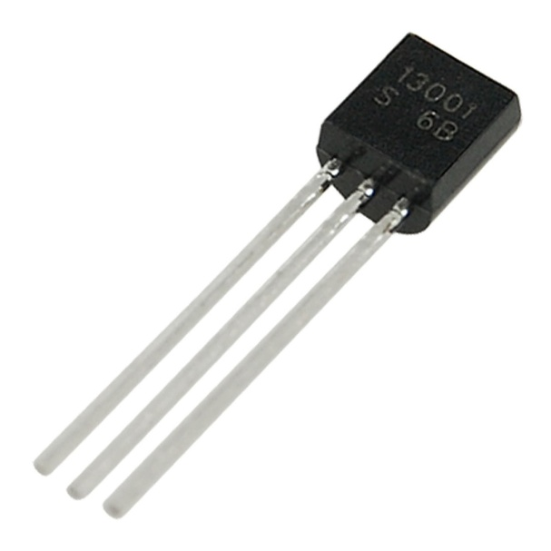

Figure 3.4.1

5. Power Supply
The power supply is responsible for providing the necessary power to the components of the system, such as the LDR, relay, transistor, and the street light.Functionality: The power supply ensures that the control circuit and sensors receive the correct voltage and current for proper operation. In grid-powered systems, a typical AC-to-DC power supply will be used to convert the AC power from the grid into DC power suitable for the system’s components.
Working Principle: If the system is grid-powered, an AC power source (e.g., 220V) will be connected to a transformer or a rectifier circuit, which will convert the AC power into low-voltage DC power, usually 12V or 5V. This DC power is then distributed to the LDR, transistor, relay, and other components.
In a solar-powered system, the power supply will include a solar panel and a battery to store and provide energy. The solar panel charges the battery during daylight hours, and the battery supplies power to the system at night.

6. Wiring and Connectors
Wiring and connectors are essential components for ensuring that the various hardware elements are correctly interconnected and can communicate with each other.
Functionality: Wires carry power and signal from one component to another. Proper wiring ensures that the components are connected securely, allowing the system to function smoothly. Connectors are used for easy assembly, disassembly, and maintenance of the system.
Working Principle: The wiring connects the LDR to the control circuit, the transistor to the relay, and the relay to the street light. Connectors are used to join the components without the risk of short circuits or loose connections.The quality and management of the wiring ensure the reliability and longevity of the system.
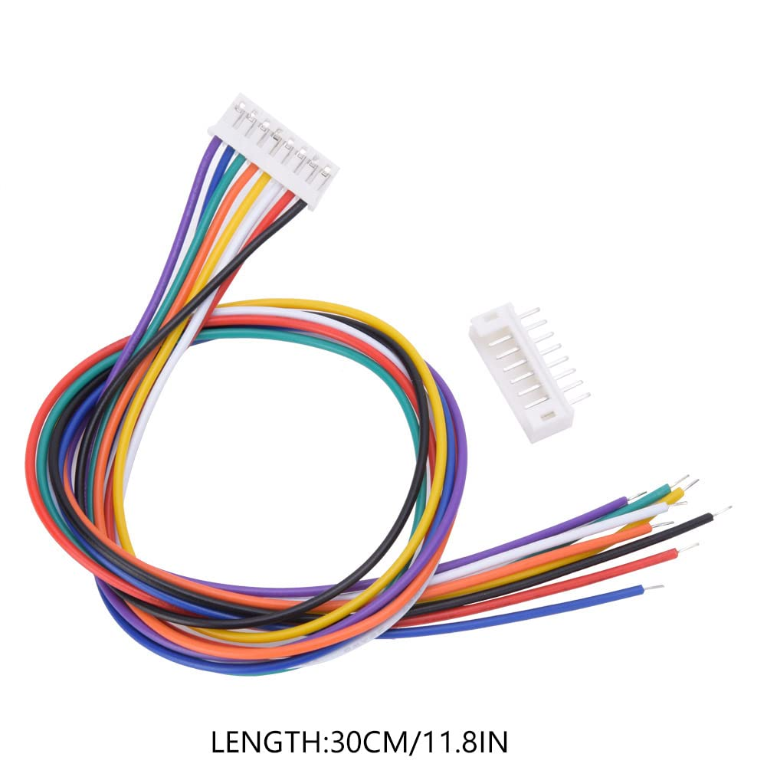

Figure 3.5.1

3.4BLOCK DIAGRAM

The automatic street light control system using an LDR operates through a simple yet effective block-wise structure, ensuring that streetlights turn on automatically during darkness and switch off when ambient light is sufficient. Each block plays a specific role in this process, forming a seamless flow from light detection to power control.At the core of the system is the Light Dependent Resistor (LDR), which functions as the primary sensor. The LDR changes its resistance based on the surrounding light levels—its resistance is low in daylight and high in darkness. This property allows it to act as a trigger for the system. When used in combination with other components, it enables the automation of street lighting without human intervention.The LDR is part of a voltage divider circuit, usually connected with a fixed-value resistor. This configuration transforms the resistance change of the LDR into a variable voltage. The output voltage of this divider shifts according to the intensity of light falling on the LDR. As ambient light decreases (i.e., during evening or night), the voltage output from the divider crosses a preset threshold, which can be detected by the next stage in the circuit.This output voltage is then fed to a comparator or a transistor switch. In basic circuits, a transistor is often used to act as a switch. When the voltage from the LDR drops below a certain level (indicating darkness), the transistor turns on. In slightly more advanced versions, a comparator is used to compare the LDR voltage with a reference value. When the LDR voltage goes below the reference, the comparator outputs a high signal to activate the next block.The relay module receives the signal from the transistor or comparator and acts accordingly. The relay works like an electronic switch, capable of controlling high-power devices like street lights using a small control signal. When the relay is energized, it closes its internal contact, allowing current to flow to the street light. This enables the system to safely operate high-voltage or high-wattage lights based on the low-power control signal.The street light (LED or lamp) is the final output of the system. It gets power from the relay only when the system detects that it's dark outside. This ensures that the street light is turned on only when necessary, reducing energy consumption and maintenance costs.Supporting all of these components is the power supply, which provides regulated DC voltage necessary for the proper functioning of the system. It ensures that the LDR, transistor, and relay modules operate reliably without voltage fluctuations.
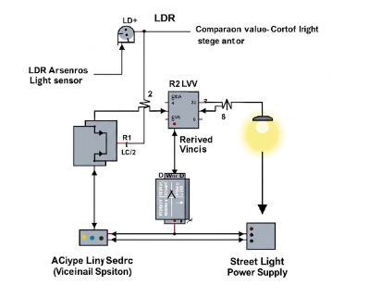
Figure 3.6

3.5Schematic Diagram

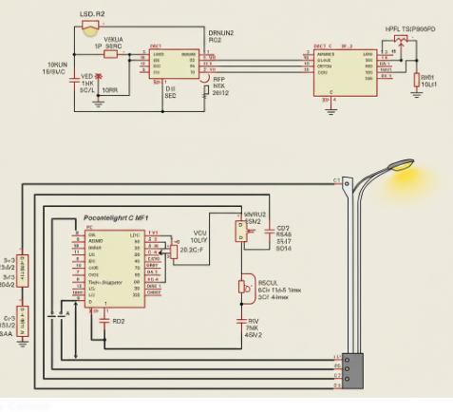
Figure 3.7

3.6 Principle of Operation
The principle of an LDR-based automatic street light control system revolves around the concept of using ambient light levels to control the switching of street lights automatically. Instead of relying on manual intervention or time-based systems, this project leverages the natural change in daylight to automate street lighting using basic electronic components. The core principle involves the use of a Light Dependent Resistor (LDR), a component whose resistance changes with light intensity, in combination with a voltage divider, transistor switch, and a relay to control the lighting system.

Basic Working Concept
At the heart of the system lies the Light Dependent Resistor (LDR). The LDR is a photoresistive sensor that decreases in resistance when exposed to light and increases in resistance in the dark. This property makes it ideal for sensing day and night conditions. During the daytime, when light is abundant, the LDR's resistance drops, allowing more current to flow through it. At night, in the absence of light, the LDR's resistance rises, reducing current flow. This change in resistance is translated into a voltage variation using a voltage divider circuit.
The voltage divider typically consists of two resistors — one of them being the LDR and the other a fixed-value resistor. These resistors are connected in series between a power supply (usually 5V or 12V) and ground. The output voltage is taken from the junction between the LDR and the fixed resistor. As the LDR’s resistance changes with light, the output voltage at this point also changes. This voltage can be monitored and compared with a reference level to determine whether it is day or night.

Comparator or Switching Mechanism
Once the voltage is generated from the voltage divider, it is compared with a predetermined threshold using a comparator or a simple transistor-based switching circuit. In more basic systems, a transistor (such as a BC547 or 2N2222) can serve as an effective switch. The base of the transistor receives the output voltage from the voltage divider. When this voltage exceeds a certain threshold (typically during daylight), the transistor remains OFF, and the relay stays open, keeping the street light OFF.However, when the ambient light drops below a certain level (i.e., at dusk), the LDR’s resistance increases, causing a rise in the voltage across the fixed resistor. If this voltage is high enough to bias the transistor, it turns ON. When the transistor is switched ON, it completes the circuit for the relay module, energizing it and causing it to close its contacts. This effectively switches ON the connected street light (usually an LED lamp or a bulb).In more sophisticated designs, an operational amplifier (op-amp) in comparator mode can replace the transistor switch to offer better precision. The op-amp compares the LDR voltage with a reference voltage set by a potentiometer or resistor divider and outputs a high or low signal based on the comparison. This output then drives the transistor or relay accordingly.
Relay Operation and Light Control
The relay is a crucial component in this system as it acts as the actual switching mechanism for the street light. It is an electrically operated switch that can handle higher current and voltage levels, making it ideal for controlling 230V AC street lights or high-power LEDs. When the relay coil is energized by the transistor’s output, its internal contact changes position, closing the circuit connected to the street light.
In the de-energized state (when the transistor is OFF due to high light levels), the relay contacts are open, and the street light remains OFF. As night falls and the transistor turns ON, the relay coil is powered, closing the contacts and turning the light ON. This cycle repeats every day, making the system highly efficient and maintenance-free.

Power Supply
To power the system, a regulated DC power supply is used. This may be a 9V or 12V battery, a wall adapter, or even a solar-powered unit for eco-friendly applications. The power supply energizes all components including the voltage divider, transistor, and relay. In some setups, voltage regulators such as the 7805 IC might be used to step down and stabilize voltage to components that require 5V.
In solar-based designs, the system is often coupled with a rechargeable battery and a solar charging circuit. The solar panel charges the battery during the day, and the system uses that stored energy to power the lights at night, all while using the LDR for automatic switching.
3.4 FINAL HARDWARE MODEL

Step 1: Collect Required Components
Gather all necessary hardware components:
- Light Dependent Resistor (LDR)
- Fixed resistor (e.g., 10kΩ)
- NPN Transistor (e.g., BC547)
- Relay module (5V or 12V depending on your supply)
- High-power LED or bulb (to act as street light)
- Diode (e.g., 1N4007) for back EMF protection
- Breadboard or PCB
- Connecting wires
- DC power supply or battery
- Soldering tools (if using PCB)

Step 2: Design the Circuit
Draw or refer to the circuit diagram:
- Connect the LDR and resistor in a voltage divider configuration.
- Connect the output of the divider to the base of the transistor via a current-limiting resistor.
- Connect the relay coil between the collector of the transistor and the positive supply.
- Place a flyback diode across the relay coil to protect the transistor from back EMF.
- Connect the emitter of the transistor to ground.
- Connect the streetlight (LED/bulb) to the relay's normally open (NO) and common (COM) contacts.
- Provide a power supply to the whole system.

Step 3: Assemble on Breadboard (for Testing)
- Place all components onto a breadboard.
- Double-check connections as per the circuit diagram.
- Use jumper wires to make clean and reliable connections.
- Connect the power supply and test how the system responds to changes in light.

Step 4: Test the Functionality
- Cover and uncover the LDR to simulate night and day.
- Check if the LED or light bulb turns ON when the LDR is in darkness and OFF in light.
- Ensure the relay clicks when switching and the transistor behaves correctly.

Step 5: Assemble on PCB (Final Model)
- If the breadboard test is successful, solder all components onto a PCB.
- Arrange components neatly and ensure that high-voltage paths are isolated from the low-voltage control section.
- Use a PCB terminal block or header pins for connecting external loads and power sources.
- Add a heat sink to the transistor if the current is high.

Step 6: Final Testing and Enclosure
- Connect the final model to the power supply.
- Test it in real-world lighting conditions.
- Place the circuit inside a protective enclosure for safety, especially if it's going to be placed outdoors.
- Make a small window or transparent cover over the LDR to allow light detection.

Step 7: Deployment
- Mount the LDR such that it faces the sky for best sensing.
- Connect the relay output to the actual street light (ensure proper voltage handling).
- Power the system using either mains (with adapter) or a solar DC source.
- Your automatic street light controller is now ready for use.

3.7 HARDWARETESTING

Hardware testing is a vital phase in ensuring the proper functionality and reliability of the LDR-based automatic street light control system. It involves verifying the correct connection and operation of each component: the Light Dependent Resistor (LDR), resistor, transistor, relay, and the lighting element (LED or bulb). The process begins with individual component testing using a multimeter.
First, the LDR is tested by measuring its resistance in varying light conditions. It should show low resistance in light and high resistance in darkness. The fixed resistor used in the voltage divider circuit is also checked to ensure its value matches the design specification. The transistor is tested for proper junction behavior, and the relay is checked by powering its coil and listening for a clicking sound, indicating actuation.
Next, the entire circuit is assembled on a breadboard for initial testing. The LDR and resistor form a voltage divider that outputs a voltage based on ambient light. This voltage is fed to the base of the transistor. In daylight, the voltage remains low, keeping the transistor off and relay deactivated, so the light stays off. In darkness, the voltage increases, switching the transistor on, which activates the relay and turns on the street light.
Testing also involves verifying the power supply’s stability and ensuring that the diode across the relay protects the transistor from back EMF. The system is tested repeatedly by simulating day and night conditions to confirm consistent behavior.
Once the breadboard prototype functions correctly, the circuit is soldered onto a PCB for the final model. The final test ensures the system works reliably in real-world conditions, completing the hardware testing phase and confirming the project’s success.
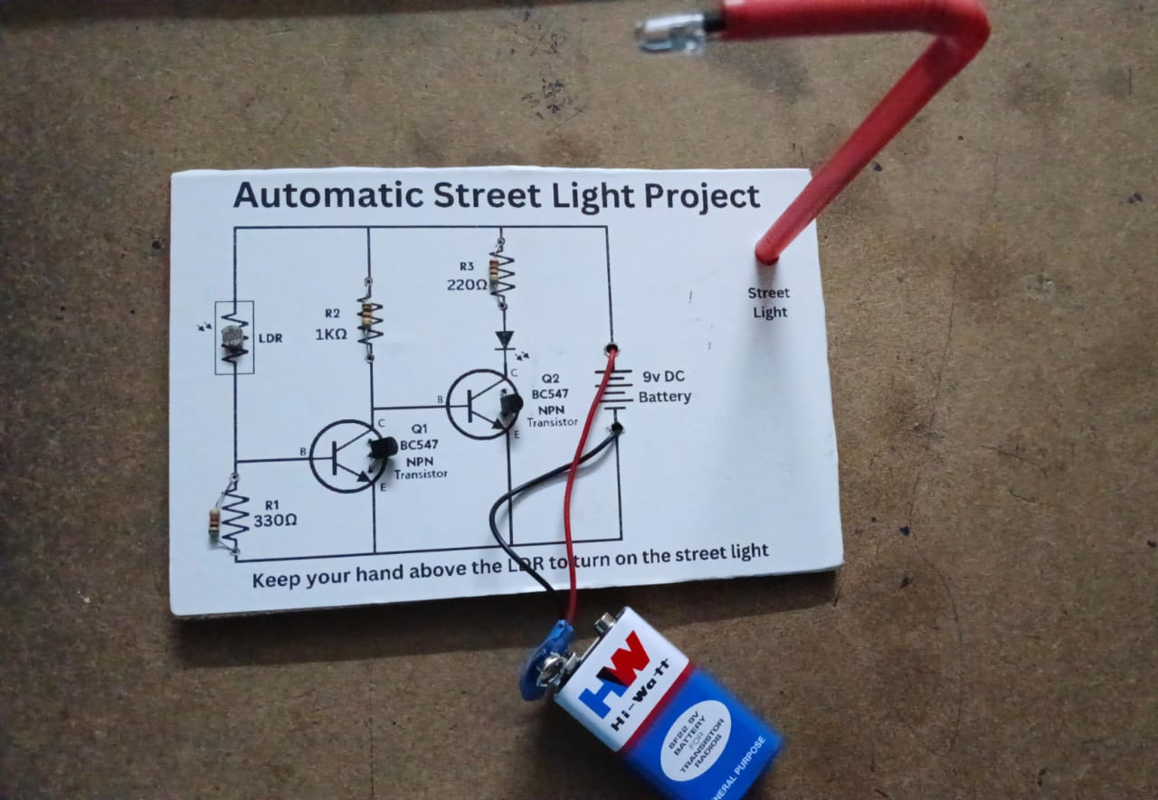
Figure 3.7

3.8ADVANTAGES
- EnergyEfficiency
The system automatically turns street lights ON at night and OFF during the day, eliminating the need for manual operation. This significantly reduces unnecessary power consumption, especially in long daylight periods.
- Low Cost and Simple Design
The project uses inexpensive and readily available components like LDRs, transistors, and relays. There’s no need for complex microcontrollers or programming, which makes it ideal for small-scale or budget-sensitive applications.
- Automatic Operation
The system is entirely autonomous. Once installed, it requires no manual intervention, reducing labor costs and minimizing the chances of human error (e.g., forgetting to switch off lights in the morning).
- Improved Lamp Lifespan
By ensuring that lights are only used when needed, the wear and tear on lamps and LEDs is reduced, thereby increasing their operational life and lowering replacement costs.
- Environmentally Friendly
Reduced electricity usage translates to a lower carbon footprint, making the system eco-friendly. When paired with solar power, it becomes even more sustainable.
- Reliable and Maintenance-Free
With fewer moving parts and no software dependency, the circuit is robust and typically requires very little maintenance once installed.
- Scalable for Different Applications
Though designed for street lights, this system can also be used in garden lights, corridor lighting, parking lots, and other outdoor lighting setups.
- Safe Operation
As the system works without manual input, it minimizes the risk of electrical hazards during switching, especially during bad weather conditions.

3.9DISADVANTAGES

- Limited Sensitivity Control
LDRs offer basic light sensing and may not provide precise control in varying light conditions such as cloudy days, fog, or artificial lighting. This can lead to lights switching ON or OFF unexpectedly.
- No Time-Based Control
The system only reacts to ambient light and doesn’t consider the time of day. In some cases, combining a timer or RTC (real-time clock) could offer more accurate control, which this simple system lacks.
- No Smart Features
Unlike microcontroller-based systems (e.g., Arduino or IoT), this project doesn't support remote monitoring, scheduling, or adaptive lighting based on real-time traffic or weather data.
- Susceptibility to False Triggering
Sudden changes in light due to passing vehicle headlights or shadows can cause the system to respond incorrectly, potentially switching the light ON or OFF unnecessarily.
- Limited Load Handling
The relay used can handle only a limited amount of current. For higher loads, a more robust relay or solid-state switch may be required, which increases cost and complexity.
- Not Weatherproof by Default
The components (especially the LDR) must be properly enclosed for outdoor installation. Without adequate weatherproofing, performance may degrade over time.
- No Fault Detection
The circuit lacks the ability to detect faults (e.g., bulb failure, power loss). More advanced systems can alert operators when something goes wrong, which this basic design cannot

CHAPTER 4

APPLICATIONS
In an age where energy efficiency, automation, and sustainability are top priorities, technologies that support these values are rapidly gaining importance. One such innovation is the LDR-based automatic street light control system. This system uses a light-dependent resistor (LDR) to sense ambient light levels and control the operation of street lights without human intervention. The applications of such a system are broad and extend far beyond just urban streets. This document explores the diverse and practical areas where such systems can be employed, enhancing efficiency, convenience, safety, and environmental responsibility.

1. Urban and Rural Street Lighting
The most obvious and widespread application of this system is in public street lighting. In both urban and rural environments, street lights are essential for ensuring the safety of pedestrians and vehicles. Traditional street lights require manual switching or are controlled by basic timers, which may not always correspond accurately with actual daylight levels.
An automatic system based on an LDR adjusts lighting dynamically based on real-time light conditions. This ensures that the lights turn on precisely at dusk and turn off at dawn, reducing electricity wastage and operational costs. In rural areas with limited access to electricity or manpower, such systems can function independently with solar-powered setups, making them even more beneficial.

2. Garden and Landscape Lighting
Residential and commercial properties often use decorative lighting for gardens, pathways, and landscapes. Typically, these lights need to be switched on manually or programmed with timers. However, an automatic street light control system can enhance the convenience and aesthetics of outdoor lighting by turning the lights on as darkness sets in and turning them off at sunrise.
Using LDRs in these scenarios not only reduces the burden on homeowners or maintenance staff but also ensures optimal energy usage. These systems can be integrated into smart home setups or solar garden lights for even greater efficiency.

3. Parking Lot Illumination
Large parking areas in shopping malls, office buildings, stadiums, and public transit terminals require extensive lighting for safety and security, especially during night hours. Using an LDR-based automatic system ensures these lights are only active when necessary, saving energy and reducing maintenance costs.
For open parking lots exposed to natural light, the LDR offers a straightforward way to manage lighting automatically, adapting to varying day lengths across seasons without needing to reprogram timers.

4. Campus and Institutional Lighting
Schools, colleges, universities, and other educational campuses often include vast outdoor spaces like walkways, sports grounds, and hostels. Maintaining lighting in these areas can be challenging, especially when campus operations are on a tight budget.
By implementing an LDR-based system, institutions can automate their outdoor lighting needs, ensuring that areas are well-lit when needed without relying on manual oversight. These systems can also contribute to environmental awareness efforts promoted by educational institutions.

5. Industrial and Warehouse Lighting
Industrial zones and warehouse areas often operate across different shifts, including night operations. Exterior lighting for these facilities is crucial for safe navigation and security. An automatic light control system based on ambient light detection provides a hands-free, low-maintenance solution to lighting needs.
Factories and warehouses can benefit significantly from the reduced operational costs and improved worker safety that result from having consistent lighting only when necessary. Moreover, solar-powered versions of this system can be installed in remote industrial sites with limited grid access.

6. Highway and Roadside Lighting
Highways and remote roads require reliable lighting to ensure road safety, especially in areas prone to accidents. Manual switching is impractical in such locations due to the extensive distance and manpower required. Using LDR-based systems provides a cost-effective and efficient solution.
This system ensures that the lights switch on automatically as darkness falls, offering better visibility to drivers and reducing accident risks. Additionally, when integrated with solar panels, these systems can provide off-grid lighting in remote or hilly areas where power infrastructure is lacking.

7. Bus Stops, Railway Platforms, and Transport Terminals
Transportation hubs such as bus stops, railway stations, and terminals operate across all hours and require adequate lighting for both functionality and security. These areas benefit greatly from automatic lighting systems, especially in outdoor spaces like platforms, waiting areas, and entryways.
An LDR-based system ensures consistent lighting, deterring potential criminal activity and helping commuters navigate the area safely during dark hours, without the need for constant human monitoring or intervention.

8. Smart City Integration
Modern smart cities emphasize automation, energy efficiency, and intelligent infrastructure. The LDR-based street light control systemaligns perfectly with these goals. It can be integrated into broader smart city grids, allowing for automated, sensor-based responses to environmental changes.
Although basic LDR-based systems are standalone, their concept can be scaled and enhanced with IoT (Internet of Things) capabilities, enabling remote monitoring, predictive maintenance, and data-driven energy management.

9. Solar Lighting Systems
In many developing regions, grid electricity is unreliable or unavailable. Solar-powered lighting systems are increasingly used in such places, and incorporating an LDR-based automatic control system makes them more efficient.
The system ensures that solar-charged lights are used only during dark hours, conserving battery life and reducing maintenance frequency. This is particularly useful for rural electrification programs, refugee camps, and disaster-relief zones.

10. Monuments and Heritage Site Illumination
Monuments, statues, and heritage buildings are often illuminated at night for aesthetic and tourism purposes. LDR-based systems ensure that such lighting only activates after sunset and deactivates automatically at dawn, reducing manual labor and electricity consumption.
In sensitive heritage sites, minimizing unnecessary lighting can also reduce light pollution and preserve the natural environment surrounding the site.

11. Security and Surveillance Lighting
Proper lighting is a crucial component of effective surveillance systems. Outdoor security cameras are significantly more effective when paired with automatic lighting that activates under low-light conditions.
Using LDRs to trigger floodlights or motion-sensor lights ensures that areas of concern remain illuminated when needed, improving visibility for cameras and deterring unauthorized activity.

12. Temporary Event Lighting
For festivals, concerts, construction sites, or emergency relief camps, temporary lighting systems are often set up outdoors. LDR-based systems can be easily integrated into these setups to automate lighting without requiring complex infrastructure or programming.
This minimizes the need for personnel to manage lighting manually and ensures energy is not wasted by leaving lights on during daylight hours.

13. Energy Management Programs
Many governments and organizations are adopting energy conservation policies and technologies. LDR-based street light systems can be included in municipal energy-saving initiatives or green building certifications.
By demonstrating a reduction in energy consumption and promoting automation, these systems support broader environmental and fiscal goals at both local and national levels.

CHAPTER-5

CONCLUSIONANDFUTURESCOPE

5.1CONCLUSION
The development and implementation of the LDR-based Automatic Street Light Control System marks a significant step forward in the evolution of energy-efficient and intelligent lighting solutions. This project not only demonstrates the practical application of fundamental electronic components such as LDRs, transistors, and relays but also addresses critical global concerns, including energy conservation, environmental protection, and automation in public infrastructure.
At its core, the system utilizes the simple yet powerful property of the Light Dependent Resistor (LDR) — its ability to change resistance in response to the intensity of ambient light. By harnessing this property, the circuit effectively automates the process of turning street lights ON at night and OFF during the day. This functionality, while basic in theory, presents profound benefits in real-world scenarios, particularly in reducing electricity wastage, eliminating human error in manual switching, and promoting operational reliability across different settings.
One of the most striking advantages of this system is its simplicity and cost-effectiveness. Unlike complex microcontroller-based systems or IoT-integrated lighting networks, this design uses basic electronic components, making it highly accessible and deployable even in resource-constrained environments. This ensures that the solution is not limited to urban or technologically advanced regions but can be extended to rural areas, developing countries, and off-grid settlements. By combining it with solar panels and rechargeable batteries, the system’s utility can be expanded further into eco-friendly and self-sustaining lighting solutions.
Through the design, simulation, and hardware testing phases, this project has also served as a rich learning experience in understanding the behavior of electronic components, circuit design, and practical prototyping. The hardware testing phase verified the integrity of each component — confirming that the LDR responded correctly to variations in light, that the transistor operated as a reliable switch, and that the relay functioned as expected to control the lighting load. These steps ensured the system’s dependability before implementation in a real-world environment.
Moreover, this project aligns strongly with contemporary goals of sustainable development and smart infrastructure. Governments and urban planners around the world are increasingly adopting automated systems to reduce maintenance costs, enhance safety, and lower the environmental impact of public services. In that regard, this project offers a scalable and adaptable model that can evolve with future technologies — for instance, integrating motion sensors for adaptive lighting, timers for time-based scheduling, or wireless modules for remote monitoring.
In practical applications, this system proves invaluable in a range of environments — from city roads and rural pathways to industrial zones, gardens, parking lots, and heritage sites. Each of these locations benefits from the automated operation of lights, reduced energy bills, and the added safety of reliable illumination after dark. The system also supports broader infrastructure goals such as reducing light pollution and encouraging responsible electricity usage.
It is also important to reflect on the limitations of this system, as understanding constraints is crucial for future improvements. The reliance solely on ambient light for operation may sometimes cause unwanted switching due to shadows, artificial lights, or rapidly changing weather conditions. Furthermore, the absence of real-time control or fault detection means the system cannot yet alert authorities in the event of light failures or circuit damage. These aspects point toward opportunities for further research and development, such as the inclusion of digital sensors, control logic, or wireless communication modules.
Despite these limitations, the project serves as a solid foundational system that achieves its intended objectives effectively. It is well-suited for small to medium-scale applications and can be a valuable prototype for educational, civic, and entrepreneurial use. Additionally, its educational value is substantial — offering insights into renewable energy integration, sensor-based automation, and the critical importance of circuit efficiency in modern electronics.
Looking to the future, this project can be a stepping stone toward more advanced smart lighting systems. By building on this foundation with microcontrollers like Arduino or Raspberry Pi, developers could program time-based operations, add features such as dimming, or connect the system to cloud-based platforms for remote access and data analytics. These developments would enhance the system’s intelligence and adaptability, aligning it with the principles of smart cities and the Internet of Things (IoT).
In conclusion, the LDR-based Automatic Street Light Control System is a practical, reliable, and eco-conscious solution to a universal challenge — the need for efficient public lighting. It underscores how simple electronic concepts, when applied thoughtfully, can have far-reaching impacts. Whether deployed in remote villages or integrated into larger municipal grids, the system has the potential to contribute meaningfully to global energy-saving efforts, improve nighttime safety, and reduce human intervention in infrastructure management. As technology continues to evolve, this project reminds us that sustainability often begins with the simplest innovations — guided by awareness, necessity, and creativity.

5.2FUTURESCOPE

Introduction
The demand for efficient and intelligent lighting solutions has grown in recent years due to the global focus on sustainability, automation, and smart city development. TheLDR-based Automatic Street Light Control System, though a simple and cost-effective solution, serves as a crucial foundational technology in the field of automated public infrastructure. While it currently performs basic tasks of switching lights ON/OFF based on light intensity, there exists immense potential to enhance and diversify its functionality through innovation and integration. This section explores the wide-ranging future scope of this system from both technological and societal perspectives.

1. Integration with Smart City Infrastructure
As cities evolve into smart ecosystems, there is a growing need for intelligent systems that can communicate, adapt, and optimize based on real-time data. Future versions of the LDR-based street light system can be integrated with smart cityplatforms, allowing lights to communicate with central control units through wireless technologies like Zigbee, LoRa, or Wi-Fi. This would enable remote monitoring, adaptive lighting, and predictive maintenance — transforming a simple circuit into a node in an intelligent grid.
For example, central control stations could monitor thousands of streetlights, gather usage data, detect failures instantly, and optimize operation schedules. Integration with traffic systems could also allow lights to brighten during high traffic periods or dim in low-use areas, contributing to smart urban planning.

2. Solar-Powered Automation and Renewable Integration
Combining LDR-based automation with solar energy systems represents a sustainable future for public lighting. As solar panels become cheaper and more efficient, the deployment of solar-powered streetlights with automated switching will gain momentum, especially in remote or underdeveloped areas.
Future designs could include solarpanels with smart battery management systems (BMS) that optimize energy storage and usage. The LDR circuit would ensure energy is used only during necessary times, prolonging battery life and reducing replacement frequency. This setup can be vital for off-grid areas or during natural disasters where electricity access is disrupted.

3. IoT and Cloud Connectivity
The integration ofInternet of Things (IoT) technology could vastly expand the functionality of this system. In future models, sensors could communicate real-time data to cloud platforms, enabling remote access, data analytics, and system health monitoring.
IoT-connected LDR-based systems could:
- Send alerts if a streetlight fails or malfunctions.
- Monitor environmental conditions (e.g., humidity, temperature).
- Track energy consumption over time.
- Predict maintenance needs before breakdowns occur.
Such intelligent systems would reduce operational costs and ensure continuous, safe lighting, especially in high-risk zones like highways, industrial parks, or school zones.

4. Adaptive Lighting Based on Traffic and Motion
Another promising direction is adaptive or dynamic lighting. Rather than relying solely on ambient light, future systems could integrate motion sensors orinfrared sensors to detect vehicles or pedestrians. This would allow lights to operate at lower intensity when the road is empty and brighten as soon as movement is detected.
Such systems reduce energy use drastically without compromising safety. Highways, industrial zones, or sparsely populated areas could benefit from motion-based lighting, extending the life of lighting infrastructure and saving power.

5. Machine Learning and AI Optimization
Machine learning (ML) and artificial intelligence (AI) offer a forward-thinking approach to managing lighting networks. Data gathered from LDR systems over time could be fed into ML algorithms to identify usage patterns, predict sunset/sunrise times based on season and geography, and even detect anomalies.
An AI-powered streetlight system could:
- Automatically adjust light sensitivity thresholds based on location or climate.
- Optimize energy distribution in real time.
- Identify abnormal behaviors (e.g., lights staying on during the day) and self-correct or notify technicians.
This self-learning capability enhances reliability and contributes to predictive and preventive maintenance strategies.

6. Integration with Emergency Systems
In future urban planning, automatic lighting could play a role in emergency response systems. Lights could flash or change color during emergencies like earthquakes, fires, or floods to guide people to safe zones.
LDR-controlled systems, when integrated with public alert systems, could enhance public safety. For example, during a power outage or blackout, battery-powered LDR systems could automatically illuminate evacuation routes without manual control.

7. Mobile App Integration and User Control
Although LDR-based systems are autonomous, future versions could allowmanual overrides via mobile applicationsfor maintenance or customization. Facility managers or municipal workers could use an app to:
- Check system health.
- Adjust light sensitivity settings.
- Control specific lights remotely.
- Schedule maintenance checks or system resets.
Such features would be useful in residential communities, educational campuses, or smart industrial parks where controlled access is important.

8. Upgraded Sensor Combinations
Currently, the LDR responds only to light intensity. However, combining it with additional sensors could significantly enhance functionality:
- PIR (Passive Infrared): Detects motion to trigger lights only when movement is sensed.
- Temperature sensors: Adjust brightness in extreme weather to conserve energy or improve visibility.
- Air quality sensors: Provide environmental data for urban monitoring when mounted on lighting poles.
This multi-sensor approach transforms the lighting infrastructure into a platform for urban data collection and environmental monitoring.

9. Cost Reduction Through Mass Adoption
As the demand for energy-saving solutions rises globally, mass production of such systems could significantly reduce the cost per unit. Future LDR-based systems could be produced at a scale where they become standard installations in every new public infrastructure project, from roads and tunnels to parks and public restrooms.
This democratization of smart lighting technology would enable widespread adoption even in economically constrained regions, aiding global energy conservation efforts.

10. Educational and Research Applications
LDR-based projects provide excellent opportunities for education, research, and innovation, particularly in schools, colleges, and technical training institutes. Future enhancements in this system could lead to open-source kits for students to explore automation, renewable energy, and embedded systems.
Through educational expansion, new ideas could emerge — such as hybrid systems that use weather forecasting to control lighting schedules or peer-to-peer streetlights that share energy through microgrids.

11. Role in Environmental Conservation
As the world becomes more conscious of energy and ecological balance, automated systems like these can directly contribute to reducing light pollution, carbon emissions, andpower plant loads.
In the future, LDR-based systems could be integrated with wildlife preservation zones, minimizing artificial light exposure that disturbs nocturnal animals. The project could be tailored to dim or shut off lights in protected areas based on predefined ecological triggers.

REFERENCES
- LDR Working Principle and Applications
https://www.electronics-tutorials.ws/io/ldr.html
Detailed explanation of how Light Dependent Resistors work.
- Transistor as a Switch
https://learn.sparkfun.com/tutorials/transistors/all
Covers how transistors are used for switching and amplification in circuits.
- Relay Module Operation
https://www.electronics-tutorials.ws/blog/relay-module.html
Explanation of relay module usage in microcontroller and analog circuits.
- Street Light Automation Using LDR – Project Guide
https://circuitdigest.com/microcontroller-projects/automatic-street-light-controller-using-relay-and-ldr
Practical guide with circuit diagram and explanation using LDR and relay.
- Solar Street Light Systems
https://www.sciencedirect.com/science/article/pii/S1364032113002777
Research paper on the integration of solar panels with street lighting systems.
- IEEE Paper: Automatic Street Light Control System
https://ieeexplore.ieee.org/document/8467097
Technical paper describing various street light automation methods.
- Arduino-Free Light Automation Circuit
https://www.engineersgarage.com/automatic-street-light-control-system/
Example of a simple, Arduino-free automation circuit using LDR and transistor.
- Application of LDR in Daily Life
https://www.elprocus.com/ldr-light-dependent-resistor/
Overview of where and how LDRs are used in real-world applications.

